**Annual performance report for: Thames Water Beckton Sludge Powered Generator**

**Permit Number: EPR/ ZP3833BK**

**Year: 2022**

This report is required under the Industrial Emissions Directive’s Article 55(2) requirements on reporting and public information on waste incineration plants and co-incineration plants, which require the operator to produce an annual report on the functioning and monitoring of the plant and make it available to the public.

**1. Introduction**

|  |  |
| --- | --- |
| Name and address of plant | Beckton Sludge Powered Generator  Jenkins Lane  Barking  Essex  IG11 0AD |
| Description of waste input | Sewage sludge |
| Operator contact details if members of the public have any questions |  |

**2. Plant description**

|  |
| --- |
| The Sludge Powered Generator (SPG) comprises of 3 identical process streams served by common utility systems. The overall dewatering and incineration capacity is 13.5 tonnes dry solids (TDS) per hour, equal to 4.5 TDS/h for each incineration stream.  The thickened mixture of primary and secondary surplus activated sludge is supplied to the sludge draw-off tanks, which work as a buffer for the batch-operated dewatering process. Sludge is dewatered via 8 (7 duty/1 standby) membrane filter presses using a solution of polyelectrolyte from a storage and make up plant as flocculation aid.  Sludge cake discharged from the presses is transferred and distributed via a trough chain conveyorsystem to 3 cake storage silos, one for each incineration stream. Sludge cake is then drawn from the silo and transferred to a rotary feeder at the incinerator. The throughput of each stream is calculated via integration of the silo loads and can be adjusted through the variable speed silo discharge screw conveyor.  Sludge incineration takes place in a fluidised bed incinerator. This consists of a cylindrical, brick-lined vertical combustion chamber where, in the lower part, a sand bed is kept in fluidizing motion by the injection of combustion air (fluidising air) through the nozzle grate. A start up burner is fitted to the inlet of a combustion chamber attached to the bottom section of the incinerator (wind box) below the nozzle grate. To enable auto-thermal (no external fuel source) operation under normal conditions fluidising air supplied through combustion chamber and wind box will be preheated in a 3 stage system.  Flue gas leaving the incinerator passes through a waste heat recovery boiler. High pressure steam of 42 bar(a) and 4000C is generated and fed to a steam turbine for power generation.  The flue gas cleaning process comprises of dust separation in a cyclone, a circulating fluidised bed process for mercury removal and a multistage scrubbing process removing pollutants to meet the emission standard. Concentrations of the relevant contaminants are continuously monitored prior to flue gas being released into the atmosphere through a single multi flue stack. |

**3. Summary of Plant Operation**

|  |  |
| --- | --- |
| Other waste received- sewage sludge | 32,891 tonnes |
| Total waste received | 32,891 tonnes |
| Total plant operational hours | Incineration Line 1: 4478 hrs  Incineration Line 2: 4048 hrs  Incineration Line 3: 4175 hrs |
| Total hours of “abnormal operation” (see permit for definition) | 0 hours |
| Total quantity of incinerator bottom ash (IBA) produced | 0 tonnes |
| Disposal or recovery route for IBA | n/a |
| Did any batches of IBA test as hazardous? If yes, state quantity | n/a |
| Total quantity of air pollution control (APC) residues produced | 3315 tonnes |
| Disposal or recovery route for APC residues | Recovery |
| Total electricity generated for export to the National Grid | 4986 MWh |

**Additional Information**

|  |  |
| --- | --- |
| Total quantity of incinerator fly ash produced | 1083 tonnes |
| Disposal or recovery route for fly ash | Recovery |
| Did any batches of fly ash test as hazardous? If yes, state quantity | N |

**4. Summary of Plant Emissions**

**4.1 Summary of continuous emissions monitoring results for emissions to air**

The following charts show the performance of the plant against its emission limit values (ELVs) for substances that are continuously monitored.

Line 1 - Hydrogen chloride

|  |
| --- |
|  |

Line 1 – Sulphur dioxide

|  |
| --- |
|  |

Line 1 – Oxides of nitrogen

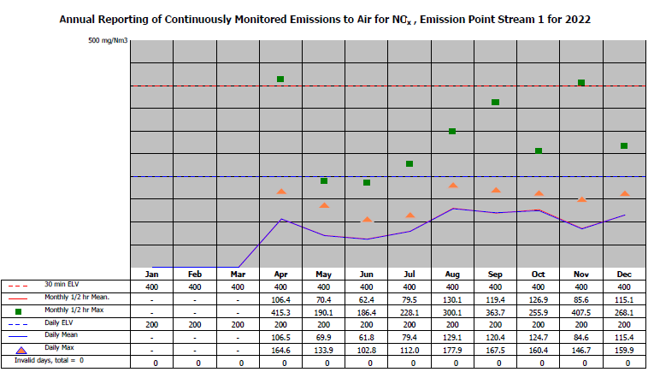

Line 1 – Total organic carbon

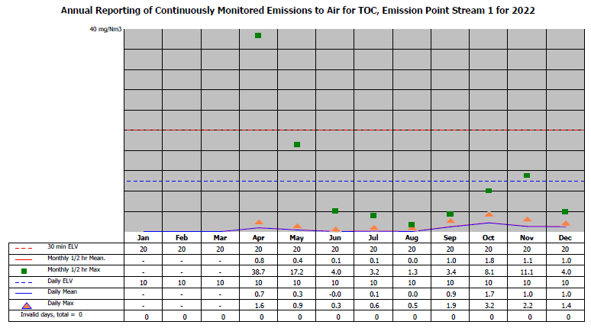

Line 1 – Particulates

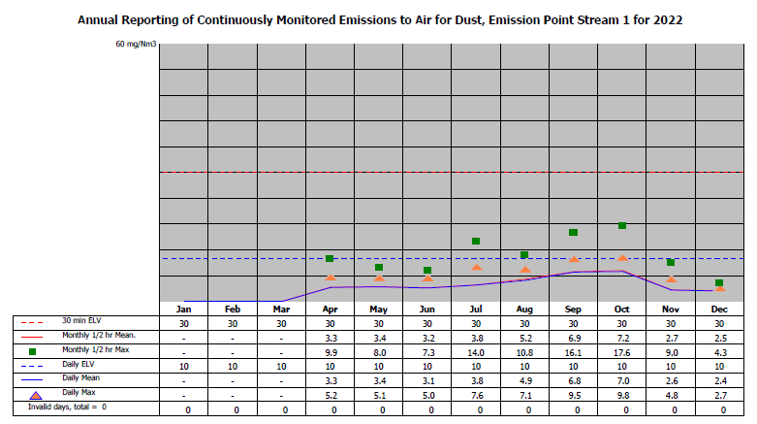

Line 1 – Carbon monoxide

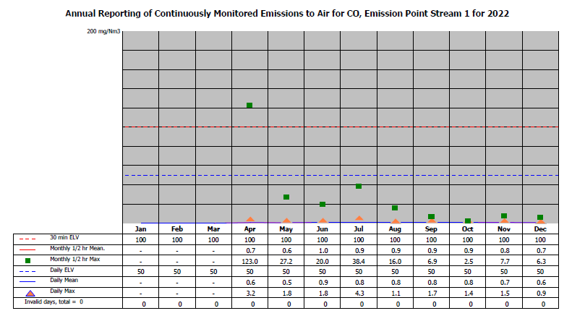

Line 1 – Ammonia

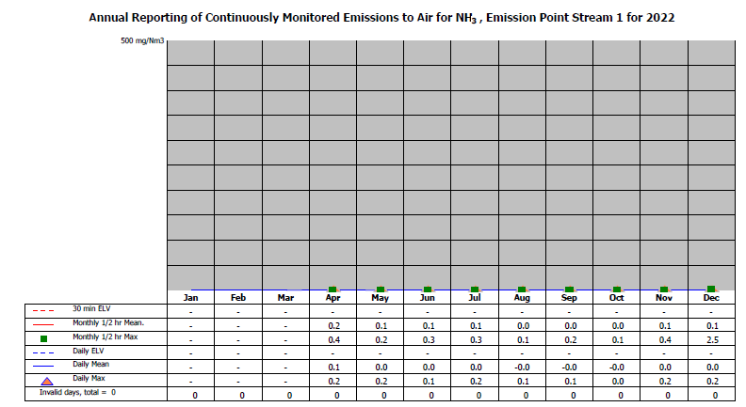

Line 2 - Hydrogen chloride

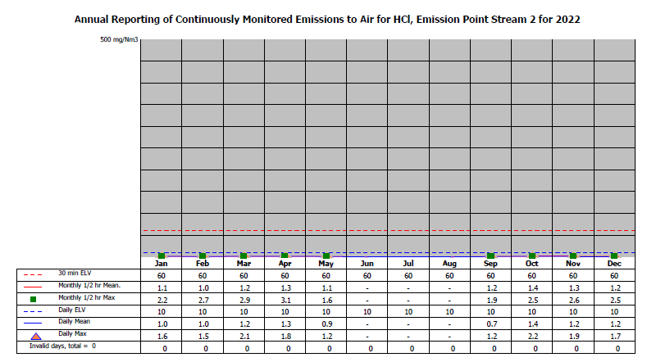

Line 2 – Sulphur dioxide

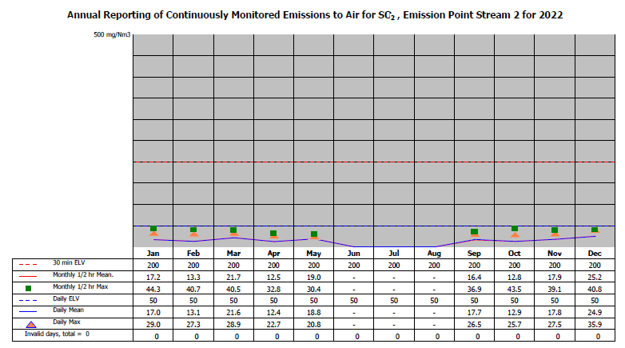

Line 2 – Oxides of nitrogen

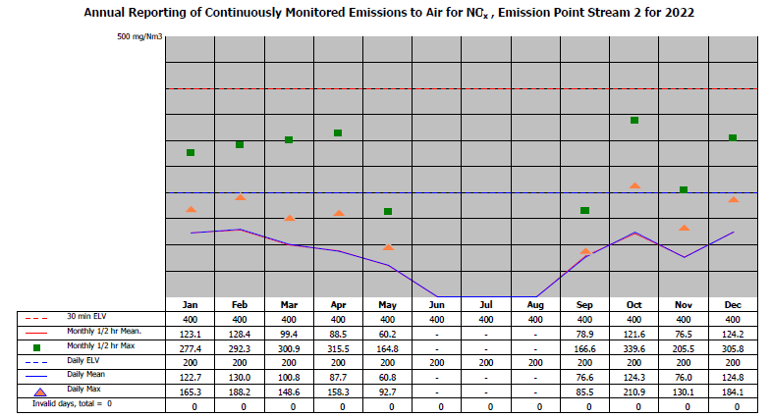

Line 2 – Total organic carbon

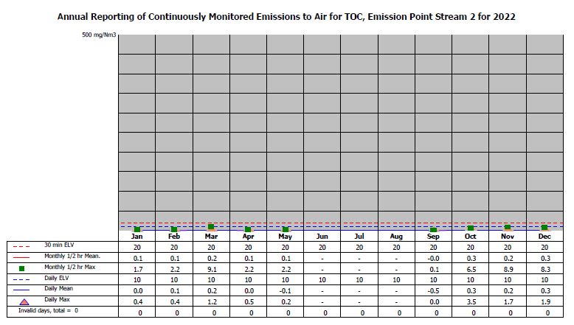

Line 2 – Particulates

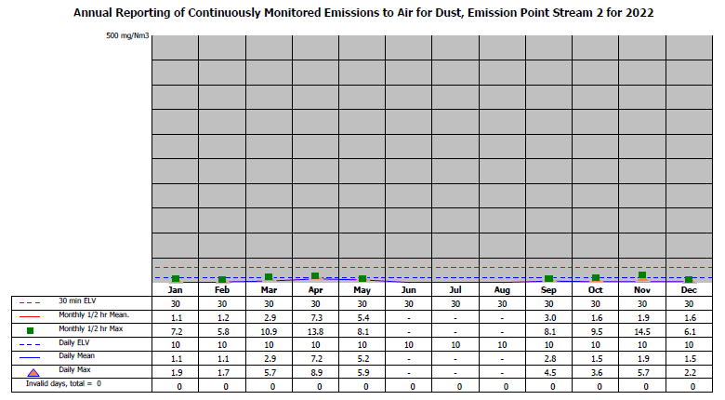

Line 2 – Carbon monoxide

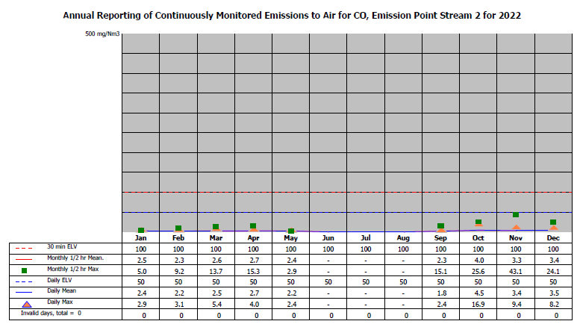

Line 2 – Ammonia

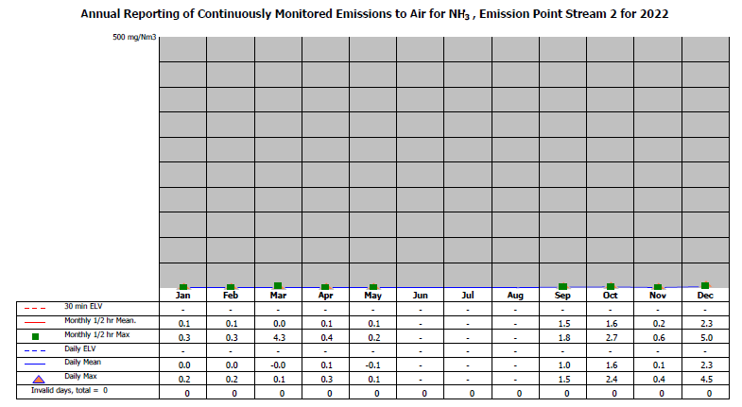

Line 3 - Hydrogen chloride

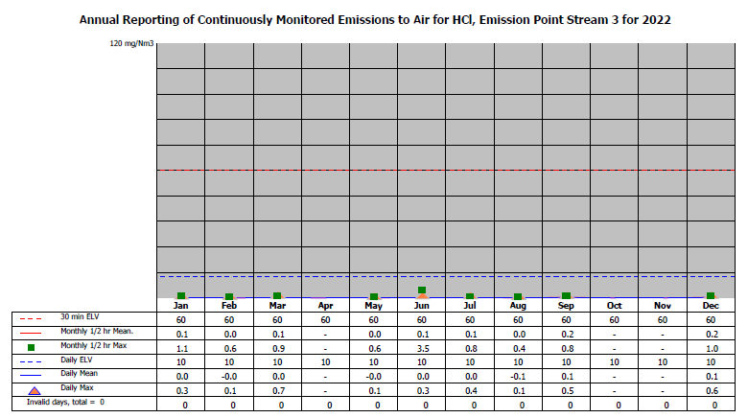

Line 3 – Sulphur dioxide

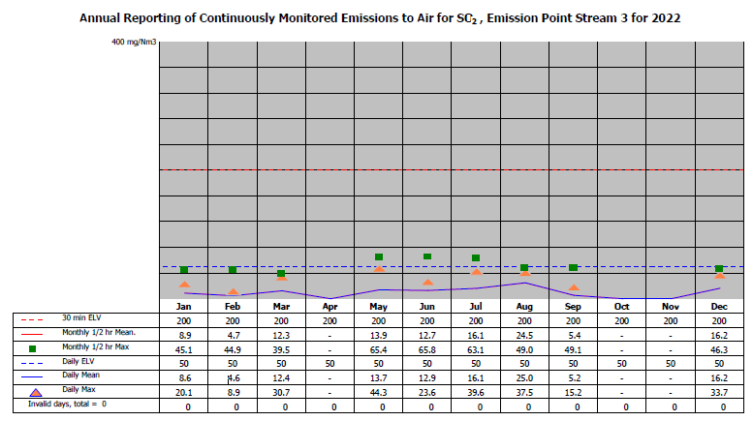

Line 3 – Oxides of nitrogen

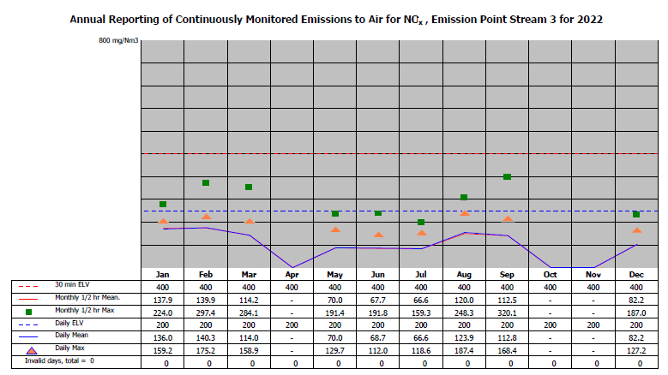

Line 3 – Total organic carbon

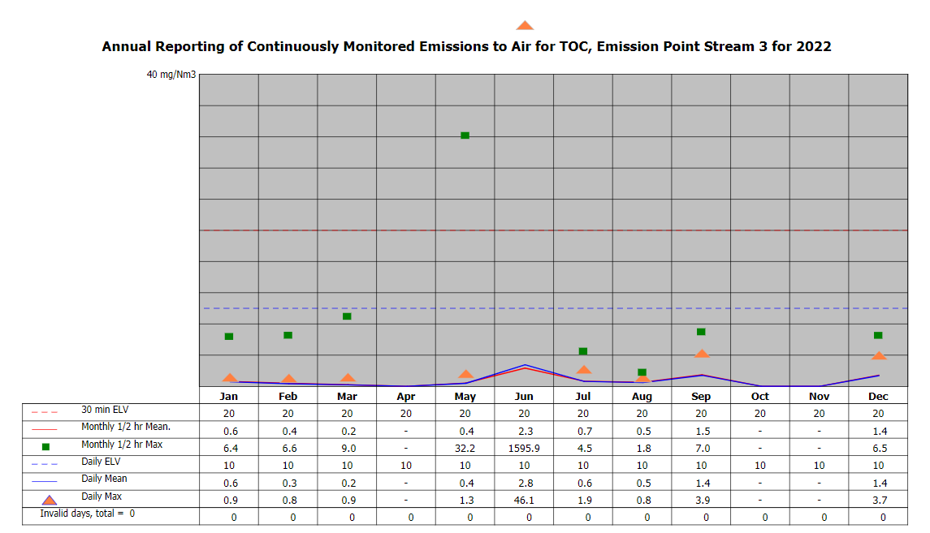

Line 3 – Particulates

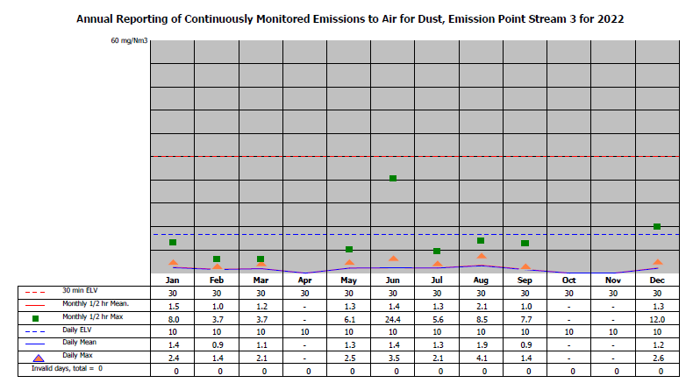

Line 3 – Carbon monoxide

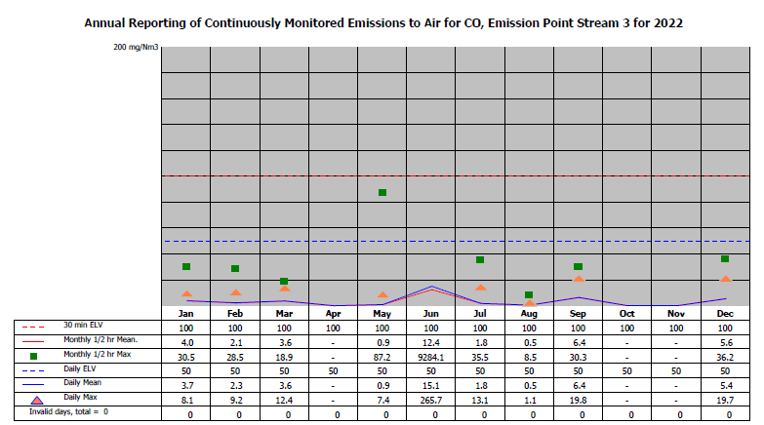

Line 3 – Ammonia

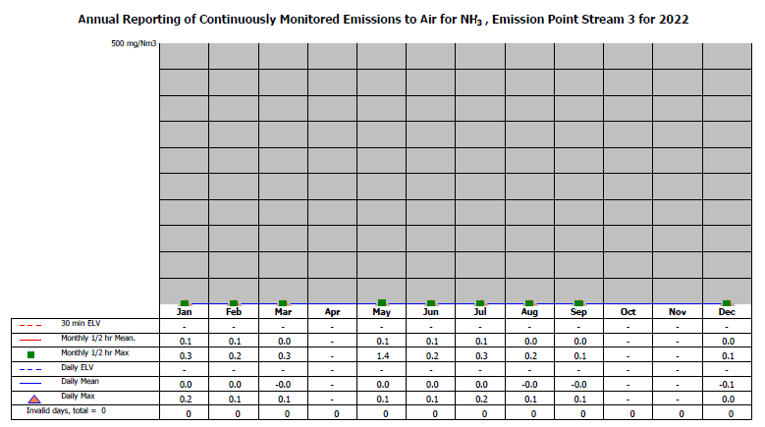

**4.2 Summary of periodic monitoring results for emissions to air**

The table below shows the results of periodically monitored substances.

**Line 1**

|  |  |  |  |
| --- | --- | --- | --- |
| **Substance** | **Emission limit value** | **Results** | |
| Not operational at time of testing | 01/08- 04/08/22 |
| Mercury and its compounds | 0.05 mg/m3 | Not operational at time of testing | 0.0004 mg/m³ |
| Cadmium & thallium and their compounds (total) | 0.05 mg/m3 | Not operational at time of testing | 0.0005 mg/m³ |
| Sb, As, Pb, Cr, Co, Cu, Mn, Ni and V and their compounds (total) | 0.5 mg/m3 | Not operational at time of testing | 0.005 mg/m3 |
| Dioxins and furans (I-TEQ) | 0.1 ng/m3 | Not operational at time of testing | 0.000011 ng/m³ |
| Hydrogen Fluoride | 2 mg/m3 | Not operational at time of testing | 0.25 mg/m3 |

**Line 2 – we have Nov Hg runs – no heavy metal data**

|  |  |  |  |
| --- | --- | --- | --- |
| **Substance** | **Emission limit value** | **Results** | |
| Not operational at time of testing | 28/01- 02/02/22 |
| Mercury and its compounds | 0.05 mg/m3 | Not operational at time of testing | 0.0056 mg/m3 |
| Cadmium & thallium and their compounds (total) | 0.05 mg/m3 | Not operational at time of testing | 0.0007 mg/m3 |
| Sb, As, Pb, Cr, Co, Cu, Mn, Ni and V and their compounds (total) | 0.5 mg/m3 | Not operational at time of testing | 0.013 mg/m3 |
| Dioxins and furans (I-TEQ) | 0.1 ng/m3 | Not operational at time of testing | 0.0005 mg/m3 |
| Hydrogen Fluoride | 2 mg/m3 | Not operational at time of testing | 1.67 mg/m3 |

**Line 3**

|  |  |  |  |
| --- | --- | --- | --- |
| **Substance** | **Emission limit value** | **Results** | |
| 24/01- 27/01/22 | 26-29/07/21 |
| Mercury and its compounds | 0.05 mg/m3 | 0.003 mg/m3 | 0.0003 mg/m3 |
| Cadmium & thallium and their compounds (total) | 0.05 mg/m3 | 0.001 mg/m3 | 0.0005 mg/m3 |
| Sb, As, Pb, Cr, Co, Cu, Mn, Ni and V and their compounds (total) | 0.5 mg/m3 | 0.042 mg/m3 | 0.006 mg/m3 |
| Dioxins and furans (I-TEQ) | 0.1 ng/m3 | 0.0016 ng/m3 | 0.0003 ng/m3 |
| Hydrogen Fluoride | 2 mg/m3 | 0.47 mg/m3 | 0.71 mg/m3 |

**4.3 Summary of monitoring results for emissions to water**

Total suspended solids

|  |  |  |  |  |  |  |  |  |  |  |  |  |
| --- | --- | --- | --- | --- | --- | --- | --- | --- | --- | --- | --- | --- |
|  | Jan | Feb | Mar | Apr | May | Jun | Jul | Aug | Sep | Oct | Nov | Dec |
| Daily ELV (mg/m3) |
| Monthly maximum | 54 | 57 | 41 | 136 | 72 | 34 | 119 | 385 | 170 | 90 | 194 | 651 |
| Monthly average | 11 | 14 | 11 | 17 | 17 | 23 | 30 | 51 | 55 | 24 | 56 | 64 |

**5.1 Summary of any notifications or non-compliances under the permit**

|  |  |  |  |
| --- | --- | --- | --- |
| **Date** | **Summary of notification or non-compliance** | **Reason** | **Measures taken to prevent reoccurrence** |
| 06/04/2022 | Notification for half-hourly exceedance for NOx. Release point BK-A-1. Compliant with permit under abnormal conditions | Steady-state conditions had not been achieved | Cake feed stopped and allowed to stabilise before re-starting. Occurred during start up. |
| 08/04/2022 | Notification for half-hourly exceedance for CO & TOC. Release point BK-A-1 | Boiler feed water diversion control valve failed in auto to the economiser (WSCT1009) which caused the flue gas temperature to increase resulting in a trip on the cyclone ESD (emergency shutdown), causing the cake feed to trip. | Cake feed stopped and allowed to stabilise before re-starting. Occurred during start-up. |
| 24/06/2022 | Notification for half-hourly exceedance for CO & TOC. Release point BK-A-3 | Cake quality deteriorated unexpectedly. Drop in bed temperature. | Continued monitoring of Emission levels.  Stopping of cake feed before daily exceedance limits are reached to prevent exceedance. |
| 09/05/2022 | Notification for half-hourly exceedance for TOC | Max gas flow on incinerator (request from NGD - Penspen) | Cake feed to taken off prior any special request that can impact combustion stability. |
|  |  |  |  |

**5.2 Summary of any complaints received and actions to taken to resolve them.**

|  |  |  |  |
| --- | --- | --- | --- |
| **Date of complaint** | **Summary of complaint** | **Reason for complaint including whether substantiated by the operator or the EA** | **If substantiated, measures to prevent reoccurrence** |
|  | None |  |  |

**6. Summary of plant improvements**

|  |
| --- |
| **Summary of any permit improvement conditions that have been completed within the year and the resulting environmental benefits.** |
| None |
| **Summary of any changes to the plant or operating techniques which required a variation to the permit and a summary of the resulting environmental impact.** |
| None |
| **Summary of any other improvements made to the plant or planned to be made and a summary of the resulting environmental benefits.** |
| Scrubber Re-Lining of Streams 1, 2 and 3 for 2022.  Annual planned shutdown schedule for statutory inspections and maintenance programme for all 3 streams.  Continued refurbishment of the flue gas ducts on all streams.  Press 6 full membrane cloth replacement for improved dewatering plant performance.  Press 4 full membrane cloth replacement for improved dewatering plant performance.  Ash Outloading System to Tankers to be upgraded in 2023.  Stream ID Fan Suction and Discharge Ductwork Replacement.  Baghouse Air Pulsing Valves Upgrade to improve baghouse efficiency. Stream 2 complete, Stream 1 and 3 due 2023. |